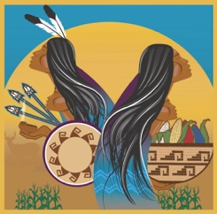
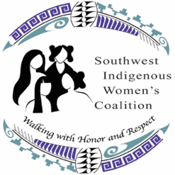
Southwest Indigenous Women’s Coalition
Gathering for Healthy Relations Conference
August 6-8, 2019

CALL FOR NOMINATIONS

ELEANOR E. ROEHRIG ADVOCATE AWARD
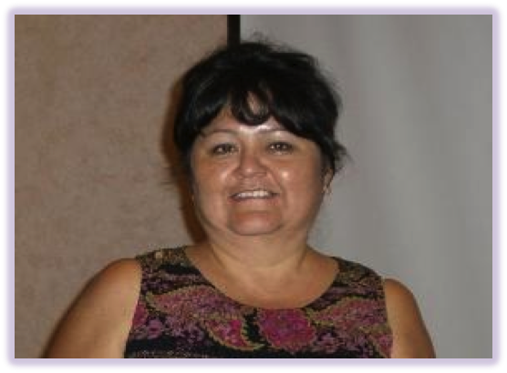
In Memoriam

Eleanor E. Roehrig, a member of the San Carlos Apache Tribe was a loving mother, grandmother, sister, niece and auntie. She was a founding members of the Southwest Indigenous Women’s Coalition (SWIWC) and the first President of the Council of Women – the governing board for SWIWC. Eleanor exemplified unyielding tenacious advocacy at the tribal grassroots level. On a state and national level Eleanor was known for her work as a thriving survivor, a dedicated advocate, and for her unrelenting aspiration to bring awareness of the domestic and sexual violence issues impacting tribal communities. Eleanor often spoke of the tragic death of one of her sisters that was the result of domestic violence and of her own survival of domestic and sexual violence. It was these experiences and her desire to protect her beloved children and grandchildren that fueled her passion in the movement to end violence against Native women. Eleanor was a gentle, but fierce woman warrior who left this world on January 08, 2010. Although she is gone, her spirit, compassion, and ambition lives on in the hearts of all who knew her.

In honor of Eleanor we will be presenting the Eleanor E. Roehrig Advocate Award to one Domestic Violence Advocate and one Sexual Violence Advocate from Arizona’s tribal communities who demonstrate commitment, compassion, and respect in responding to victims of domestic and sexual violence. Individuals should have a sound understanding of victim-centered advocacy, the dynamics of domestic and sexual violence, and the commitment to upholding safety, justice, healing, and offender accountability.

The awards will be presented during a luncheon ceremony at the 6th Gathering for Healthy Relations Conference.

Please submit nominations to:
Leanne Guy, Executive Director
leanne.guy@swiwc.org

Deadline for submissions: July23, 2019

Southwest Indigenous Women’s Coalition
Gathering for Healthy Relations Conference
August 6-8, 2019

NOMINATION FORM

ELEANOR E. ROEHRIG ADVOCATE AWARD

Nominee’s Name: __________________________________ Title:____________________________________

Contact Information (PH/Email): _______________________________________________________________

Tribe: _____________________________ Organization: ___________________________________________

Nomination for:
Domestic Violence Advocate Award Sexual Violence Advocate Award

- Provide a brief statement describing how the nominee has demonstrated commitment, compassion, tenacity, and respect in responding to victims of domestic and sexual violence. (250 word limit)

- Provide examples of how the nominee has demonstrated a sound understanding of victim-centered advocacy, the dynamics of domestic and sexual violence, respecting autonomy, providing safety, justice, healing, and offender accountability. (200 word limit)

- Is there a particular story that can be shared about the nominee’s work that illustrates the impact made in addressing domestic and sexual violence in their tribal community or communities? (250 word limit)

- Please provide any other information you would like to share about the nominee’s character and level of dedication, compassion and passion for the work in the movement to end violence. (150 word limit)

Nominator’s Name:

Nominator’s Contact Information (PH/Email):

Nominator’s Relationship to Nominee:

Tribal Community/Program:

Please submit your nominations to:
Leanne Guy at leanne.guy@swiwc.org
Deadline: July 23, 2019

